PORCUPINE MARINE NATURAL HISTORY SOCIETY
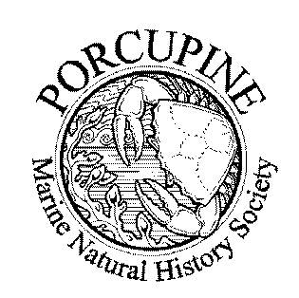

ANNUAL MEETING 2005

COLLECTIONS, COLLECTORS, COLLECTING

18 to 20 March 2005
at The Natural History Museum, Cromwell Road, London SW7 5BD

Offers of talks and/or posters, either on the theme or on any appropriate subject, are welcome now. We shall attempt to accommodate talks of from 20 to 30 minutes into the programme. Please specify equipment requirements.
Speakers so far include:
Martin Angel: Towards an Atlas of North Atlantic Planktonic Ostracoda
Geoff Moore: Richard Elmhirst: the 'other' Cumbrae naturalist
Kim Last: Biological rhythms of Nereis virens
Brian Bett: Viewing the depths of the sea
Peter Davis: '19th century marine biology in north east England'
CCW: Distribution and character of Sabellaria alveolata reefs around Wales
Jean-Claude Dauvin: Marine census of benthic invertebrates in The English Channel
The Conference Dinner will be held on the Friday night. Advance notice of intention to attend the dinner (plus payment of a deposit of £10) is essential.
Sunday 20th involves laboratory study of historic samples from west of Ireland held in the NHM collections, both sorted (to major taxon) and unsorted samples and including plankton; delegates are welcome to bring their own microscopes. Advance expressions of interest are required in order to ensure sufficient space for those wishing to attend, and particularly regarding the taxa in which attendees may be interested.
A social gathering has been organized for those staying over Saturday night.
Options for accommodation will be circulated to those requesting them.
The registration fee for the conference, inclusive of tea, coffee, etc., but not lunches or dinners is £30 for members, £35 for non-members, with a reduced rate of £10 for bona fide students and for speakers.
Please contact either Roger Bamber (R.Bamber@nhm.ac.uk) or Roni Robbins (ronr@nhm.ac.uk) of the Zoology Department of the Museum. Fax: 020 7942 5433.
See the web page - www.pmnhs.co.uk - for an on-line booking form.

